

Antibiotic Prophylaxis Against Infective Endocarditis
Implementation Advice

This advice has been provided to facilitate the implementation of NICE Clinical Guideline 64 (CG64) Prophylaxis Against Infective Endocarditis.
This advice does not replace NICE CG64.

August 2018

Scottish Dental Clinical Effectiveness Programme
Dundee Dental Education Centre, Frankland Building,
Small’s Wynd, Dundee DD1 4HN
Email scottishdental.cep@nes.scot.nhs.uk
Tel 01382 425751 / 425771
Website www.sdcep.org.uk

Contents
Foreword 2
NICE Statement of Endorsement 3
1 Introduction 4
1.1 Supporting Tools 6
2 Overview of Existing Guidelines 7
2.1 National Institute for Health and Care Excellence 7
2.2 European Society of Cardiology and American Heart Association 8
3 Obtaining Valid Consent 9
4 Advice on the Provision of Antibiotic Prophylaxis Against Infective Endocarditis 10
4.1 Patients at Increased Risk of Infective Endocarditis 10
4.2 Routine Management 12
4.3 Non-routine Management 13
4.4 Management of Children with Cardiac Conditions 14
4.5 Definition of Invasive Dental Procedures 15
4.6 Treatment of Emergency Patients 16
4.7 Prescribing Advice 17
Appendix 1 Development of this Implementation Advice 22
Appendix 2 Summary Flowchart: Management of Patients at Increased Risk of Infective Endocarditis 26
Appendix 3 Points to Cover During Antibiotic Prophylaxis Discussion with Patient 27
Appendix 4 Patient Information 30
Appendix 5 Template Letter 31
Appendix 6 Recommendations For Future Research 32
References 33

Foreword
In 2016 the National Institute for Health and Care Excellence (NICE) amended recommendation 1.1.3 of Clinical Guideline 64 Prophylaxis Against Infective Endocarditis (CG64) to include ‘routinely’ as follows:
‘Antibiotic prophylaxis against infective endocarditis is not recommended routinely for people undergoing dental procedures’.
In 2017, the Scottish Dental Clinical Effectiveness Programme (SDCEP) convened a short-life working group to develop advice for the dental team to help clarify and facilitate the implementation of the amended NICE guideline.
It was not NICE’s objective for the amended recommendation to result in a change in current practice, nor is it expected that the provision of antibiotic prophylaxis will change significantly following publication of this implementation advice. The vast majority of patients at increased risk of infective endocarditis will not be prescribed prophylaxis. However, for a very small number of patients, it may be prudent to consider antibiotic prophylaxis (non-routine management), in consultation with the patient and their cardiologist or cardiac surgeon.
It should be noted that the purpose of the SDCEP short-life working group was not to re-assess the evidence used by the NICE guideline committee or to critically appraise other relevant evidence but to offer advice on how to implement CG64. However, the methodological quality of two particularly relevant guidelines, from the European Society of Cardiology (ESC) and the American Heart Association (AHA), was assessed. Other supplementary references cited in this document have been included to provide context and background information.

NICE Statement of Endorsement
Antibiotic Prophylaxis against Infective Endocarditis: Implementation Advice This implementation advice supports the implementation of recommendations in the NICE guideline on prophylaxis against infective endocarditis.*

National Institute for Health and Care Excellence
July 2018

*© NICE [last updated 2016] Prophylaxis against infective endocarditis: antimicrobial prophylaxis against infective endocarditis in adults and children undergoing interventional procedures.
Available from www.nice.org.uk/guidance/cg64. All rights reserved. Subject to Notice of rights. NICE guidance is prepared for the National Health Service in England. All NICE guidance is subject to regular review and may be updated or withdrawn. NICE accepts no responsibility for the use of its content in this product/publication.

1 Introduction
Infective endocarditis (IE) is a rare (less than 1 case per 10,000 individuals per year in the general population)¹⁻³ but life-threatening infection of the endocardium, particularly affecting the heart valves. It can be difficult to diagnose, case fatality rates are approximately 30%^{4,5} and there is significant morbidity, with around 50% of IE patients requiring corrective cardiac surgery.^{2,5,6}{, 2014 #30} Although patients with some predisposing cardiac conditions are known to be at increased risk of IE, around 50% of new IE cases have no known pre-existing cardiac disease.^{2,7} Most cases in patients with a predisposing cardiac condition are caused by a bacterial infection originating from a transient bacteraemia.^{2,4,6} Although oral streptococci have been implicated in up to 45% of IE cases, recent reports suggest that the proportion of IE cases involving oral streptococci has fallen.^{1,2,4-6,8} The number of IE cases which originate from an invasive dental procedure appears to be low, with only 2-5% of IE patients having undergone such a procedure in the 3-12 months prior to their diagnosis.⁹⁻¹¹ However, it should be noted that a lack of robust microbiological data is a particular weakness of the supporting literature.
Previously, sporadic high-grade bacteraemias caused by invasive dental procedures were thought to be the main risk factor for IE of oral origin, with consequent widespread use of antibiotic prophylaxis. However, it is now believed that cumulative, low grade bacteraemias, triggered by normal daily activities such as tooth brushing, flossing and chewing, are of greater significance, emphasising the importance of maintaining good oral hygiene. Additionally, the evidence-base for the efficacy of antibiotic prophylaxis in preventing IE is weak and views on the risk-benefit analysis have shifted in recent years, with moves to reduce the utilisation of antibiotic prophylaxis.
Prior to 2008 in the UK, antibiotic prophylaxis against IE prior to invasive dental procedures was recommended practice for certain groups of patients with predisposing cardiac conditions. In 2008, the National Institute for Health and Care Excellence (NICE) issued Clinical Guideline 64 (CG64){, 2008. Updated 2015. Amended 2016. #15} on Prophylaxis against infective endocarditis.¹²{, 2008. Updated 2015. Amended 2016. #15}{, 2008. Updated 2015. Amended 2016. #15}{, 2008. Updated 2015. Amended 2016. #15}{, 2008. Updated 2015. Amended 2016. #15}{, 2008. Updated 2015. Amended 2016. #15}{, 2008. Updated 2015. Amended 2016. #15}{, 2008. Updated 2015. Amended 2016. #15}{, 2008. Updated 2015. Amended 2016. #15}{, 2008. Updated 2015. Amended 2016. #15}{, 2008. Updated 2015. Amended 2016. #15} Recommendation 1.1.3 stated that ‘antibiotic prophylaxis against infective endocarditis is not recommended for people undergoing dental procedures’ and subsequently the prescribing of amoxicillin (3 grams), the most commonly used drug and dose for prophylaxis, was significantly reduced.¹³ Advice on antibiotic prophylaxis in dentistry was removed from the British National Formulary (BNF), and other sources of advice for dentists quoted NICE recommendation 1.1.3 verbatim.^{14,15}
Following publication of a study¹⁶ suggesting that the incidence of IE in the UK may have been affected by the 2008 NICE guidance, the NICE guideline committee carried out a thorough review of the evidence in 2015. It found that there was no new evidence to determine whether antibiotic prophylaxis reduces the incidence of IE after interventional procedures and recommendation 1.1.3 in the guideline remained unchanged. Additionally, a 2013 Cochrane review¹⁷{Glenny, 2013 #18}{Glenny, 2013 #18}{Glenny, 2013 #18} found insufficient evidence to determine whether antibiotic prophylaxis is effective or ineffective in people considered at risk of IE who are about to undergo an invasive dental procedure. Furthermore, there is the potential for adverse reactions to these drugs.
In 2016, recommendation 1.1.3 was amended to include ‘routinely’ as follows:
‘Antibiotic prophylaxis against infective endocarditis is not recommended routinely for people undergoing dental procedures’.
In an accompanying explanatory note, NICE stated that:
'Routinely' has been added to recommendation 1.1.3 for consistency with recommendation 1.1.2. This addition emphasises NICE's standard advice on healthcare professionals' responsibilities. Doctors and dentists should offer the most appropriate treatment options, in consultation with the patient and/or their carer or guardian. In doing so, they should take account of the recommendations in this guideline and the values and preferences of patients, and apply their clinical judgement.’
The significant challenge facing dentists in the UK is that this 2016 amendment to the NICE guideline does not define which individual patient should be considered for ‘non-routine’ management. Additionally, there is no information on which antibiotic prophylaxis regimen(s) would be appropriate for use in a dental setting. This has led to confusion amongst dental practitioners and thus wide variation in how the recommendation may be implemented in practice. To address this, the Scottish Dental Clinical Effectiveness Programme (SDCEP) convened a short-life working group to develop advice for the dental team to facilitate the implementation of the NICE guideline. Further details about SDCEP and the development of this implementation advice are given in Appendix 1.
It is not expected that standard practice will change following publication of this implementation advice and antibiotic prophylaxis is not the default option for most patients at increased risk of IE. However, a very small number of patients may require special consideration for prophylaxis, which will require discussion with the patient and liaison with the patient’s cardiac specialist(s).
As with all SDCEP publications, the information presented here does not override the individual responsibility of the healthcare professional to make decisions appropriate to the individual patient, with their valid consent. It is advised that significant departures from this implementation advice, and the reasons for this, are documented in the patient’s clinical record.

1.1 Supporting Tools
Other resources to support this advice are presented in the appendices and are available to download from the SDCEP website, www.sdcep.org.uk.
- Appendix 2 - Summary Flowchart
- Appendix 3 - Points to Cover During Antibiotic Prophylaxis Discussion with Patient
- Appendix 4 – Patient Information
- Appendix 5 - Template Letter
2 Overview of Existing Guidelines
In addition to the National Institute for Health and Care Excellence (NICE) Clinical Guideline 64{, 2008. Updated 2015. Amended 2016. #15}, guidelines from two other professional organisations, the European Society of Cardiology (ESC) and the American Heart Association (AHA) informed this implementation advice. The methodological quality of these guidelines was assessed using the AGREE II instrument (see Appendix 1 and www.agreetrust.org.) and these sources were judged to be sufficiently reliable to inform this implementation advice.

2.1 National Institute for Health and Care Excellence
NICE Clinical Guideline 64 (CG64) Prophylaxis against infective endocarditis¹²{, 2008. Updated 2015. Amended 2016. #15}{, 2008. Updated 2015. Amended 2016. #15}{, 2008. Updated 2015. Amended 2016. #15}{, 2008. Updated 2015. Amended 2016. #15}{, 2008. Updated 2015. Amended 2016. #15}{, 2008. Updated 2015. Amended 2016. #15}{, 2008. Updated 2015. Amended 2016. #15}{, 2008. Updated 2015. Amended 2016. #15}{, 2008. Updated 2015. Amended 2016. #15}{, 2008. Updated 2015. Amended 2016. #15} addresses several review questions, including:
‘Does antibiotic prophylaxis in those at risk of developing IE reduce the incidence of IE when given before a defined Interventional Procedure?’
In the 2015 update to CG64,¹² the NICE guideline committee found very low quality evidence from two case-control studies and one retrospective cohort study, including people with various underlying cardiac diseases, to address this question. All studies had a high risk of bias, none reported on adverse events of prophylaxis and all were inconclusive about the efficacy of antibiotic prophylaxis before an interventional procedure to reduce the incidence of infective endocarditis (IE).
NICE stated that there does appear to be a global increase in cases of IE in both low and high risk individuals. A 2014 study¹⁶ suggested that the incidence of IE in the UK may have been affected by the introduction of CG64. However, NICE noted that this increase is observed both in countries where antibiotic prophylaxis against IE is more likely to be prescribed to high risk individuals and in the UK, where antibiotic prophylaxis is less likely to be given. In its critique of the 2014 study, the NICE guideline committee expressed concerns about the statistical models used to analyse the data and assessed the study’s findings to be at high risk of bias. NICE concluded that ‘the longstanding increase in the incidence of infective endocarditis in the UK and other countries globally is not well understood and could be due to a number of factors’.¹²

2.2 European Society of Cardiology and American Heart Association
Current guidelines from two other professional organisations also limit the extent of antibiotic prophylaxis, but provide more information about situations where it may be appropriate to prescribe.
The ESC Guidelines for the Management of Infective Endocarditis (2015)¹⁸ recommend that:
‘Antibiotic prophylaxis should only be considered for patients at highest risk for endocarditis…undergoing at risk dental procedures…and is not recommended in other situations.’
This recommendation is based on expert opinion.
The AHA guideline Prevention of Infective Endocarditis (2007)¹⁹ states that:
‘No published data demonstrate convincingly that the administration of prophylactic antibiotics prevents IE associated with bacteraemia from an invasive procedure.’
However, the guideline recommends that:
‘In patients with underlying cardiac conditions associated with the highest risk of adverse outcomes from IE…, IE prophylaxis for dental procedures is reasonable, even though we acknowledge that its effectiveness is unknown.’
This recommendation is based on data derived from non-randomised studies.
Although both of these guidelines acknowledge that the evidence supporting antibiotic prophylaxis is weak and that there is a risk of serious adverse events, each states that the rationale for recommending consideration of prophylaxis for highest risk individuals is that these patients are likely to have worse outcomes from an episode of IE.

3 Obtaining Valid Consent
The case of ‘Montgomery v Lanarkshire Health Board’²⁰ has resulted in a fresh focus on consent. Prior to this, it could be successfully argued that, in order to obtain valid consent, the patient should (only) be given the information that another clinician would give in the same circumstances. The Montgomery decision requires a clinician to inform a patient about ‘material risks’ and to find out what that specific patient would want to know. In the case of a child who is unable to consent for themselves, the clinician should inform the person with appropriate parental responsibility for that child about the specific ‘material risks’. Similar principles apply to adults lacking the capacity to consent. The case brings the law into line with the guidance issued by the regulatory bodies.
It is a general principle that healthcare professionals must obtain valid consent before starting treatment or physical investigation, or providing personal care, for a patient. The process for obtaining consent requires a discussion with the patient about the treatment options available to them, including the option of doing nothing, which will in turn facilitate shared decision-making.
This principle is covered in Standards 3.1, 3.2 and 3.3 of the General Dental Council’s ‘Standards for the Dental Team’.²¹ NICE's standard advice on healthcare professionals' responsibilities¹² also stresses the importance of offering the most appropriate treatment options in consultation with the patient, while taking into account their values and preferences.
When discussing treatment options with a patient:
- Take reasonable steps to ensure that the patient is aware of any material risks and benefits involved in all reasonable treatment options (including no treatment).
- Ensure that a contemporaneous note of your discussion with the patient is recorded in the clinical records, including the specific advice given to the patient, details of the options (and risks and benefits) discussed, the patient’s responses and a note of the patient’s autonomous decision.

4 Advice on the Provision of Antibiotic Prophylaxis Against Infective Endocarditis
Antibiotic prophylaxis is NOT recommended routinely for people undergoing dental procedures.¹²
NICE Clinical Guideline 64

4.1 Patients at Increased Risk of Infective Endocarditis
NICE recommends that healthcare professionals should regard people with the following cardiac conditions as being at increased risk of developing infective endocarditis:¹²
- acquired valvular heart disease with stenosis or regurgitation;
- hypertrophic cardiomyopathy;
- previous infective endocarditis*;
- structural congenital heart disease*, including surgically corrected or palliated structural conditions, but excluding isolated atrial septal defect, fully repaired ventricular septal defect or fully repaired patent ductus arteriosus, and closure devices that are judged to be endothelialised;
- valve replacement*.
*These categories include a sub-group of patients who will require special consideration (see below and Table 4.1)
While the vast majority of patients at increased risk of infective endocarditis (IE) will receive their dental treatment without antibiotic prophylaxis (routine management, see Section 4.2), a small sub-group will require special consideration for non-routine management (see Section 4.3).
Patients Requiring Special Consideration
The following sub-group of the increased risk patients, as identified by the ESC¹⁸ and AHA¹⁹ guidelines, require special consideration for non-routine management (also illustrated in Table 4.1). As well as being at increased risk of IE, these patients are also considered to be at particularly high risk of developing serious and potentially life-threatening complications. Note that some of the terms used by the ESC and AHA to describe the cardiac conditions in this sub-group vary from those used by NICE:
- patients with any prosthetic valve, including a transcatheter valve, or those in whom any prosthetic material was used for cardiac valve repair;
- patients with a previous episode of infective endocarditis;
- patients with congenital heart disease (CHD):
  - any type of cyanotic CHD;
  - any type of CHD repaired with a prosthetic material, whether placed surgically or by percutaneous techniques, up to 6 months after the procedure or lifelong if residual shunt or valvular regurgitation remains.
This list is mainly based on expert opinion and patients in this sub-group require special consideration for non-routine management when undergoing invasive dental procedures. The identification and assessment of these patients will require liaison with their cardiology consultant, cardiac surgeon or the local cardiology centre. The number of patients requiring special consideration is likely to be small and therefore most dental practices would be expected to have very few of these individuals registered.
Table 4.1 Identifying the special consideration sub-group
Patients at increased risk of IE |  | Sub-group requiring special consideration
- acquired valvular heart disease with stenosis or regurgitation;  - hypertrophic cardiomyopathy;  - previous infective endocarditis;  - structural congenital heart disease, including surgically corrected or palliated structural conditions, but excluding isolated atrial septal defect, fully repaired ventricular septal defect or fully repaired patent ductus arteriosus, and closure devices that are judged to be endothelialised;  - valve replacement. |  | - prosthetic valve, including transcatheter valves, or where any prosthetic material was used for valve repair;  - previous infective endocarditis;  - congenital heart disease (CHD):  - any type of cyanotic CHD;  - any type of CHD repaired with a prosthetic material, whether placed surgically or by percutaneous techniques, up to 6 months after the procedure or lifelong if residual shunt or valvular regurgitation remains.
Note that if a patient has a cardiac condition or has undergone a cardiac procedure that does not appear in Table 4.1, for example a stent or a pacemaker, then they are not considered to be at increased risk of IE and antibiotic prophylaxis is not required.
For all patients at increased risk of infective endocarditis:
- Assess whether the patient should be considered for routine or non-routine management based on their specific cardiac condition (see Table 4.1 and Appendix 2).
  - Patients who have a cardiac condition from the special consideration subgroup may require non-routine management. These special consideration patients should be assessed in consultation with their cardiology consultant, cardiac surgeon or local cardiology centre (see Section 4.3).
- If a patient is unsure about the nature of their cardiac condition, contact their cardiology consultant, cardiac surgeon or local cardiology centre for further information.

4.2 Routine Management
Routine management, where invasive dental treatment is provided without antibiotic prophylaxis, will be appropriate for the vast majority of patients at increased risk of infective endocarditis.
- Ensure that the patient and/or their carer or guardian are aware of their risk of infective endocarditis and provide advice about prevention, including:
  - the potential benefits and risks (see Section 4.7) of antibiotic prophylaxis, and an explanation of why antibiotic prophylaxis is not routinely recommended;
  - the importance of maintaining good oral health;
  - symptoms that may indicate infective endocarditis and when to seek expert advice;
  - the risks of undergoing invasive procedures, including non-medical procedures such as body piercing or tattooing.
- Record that this discussion has taken place in the patient’s clinical notes.
- If, following this discussion, the patient requests antibiotic prophylaxis, consider seeking advice from their cardiology consultant, cardiac surgeon or local cardiology centre.
  - NICE CG64¹² advises that ‘doctors and dentists should offer the most appropriate treatment options, in consultation with the patient and/or their carer or guardian’ and that the final decision should take account of ‘the values and preferences of patients’.
- Ensure that any episodes of dental infection in patients at increased risk of infective endocarditis are investigated and treated promptly to reduce the risk of endocarditis developing.
A list of points to cover in your discussion with the patient can be found in Appendix 3. A leaflet with information for the patient can be found in Appendix 4. It may also be helpful to discuss the issues surrounding antibiotic resistance with the patient.

4.3 Non-routine Management
An assessment, carried out in consultation with the patient’s cardiology consultant, cardiac surgeon or other cardiac specialist, is necessary to determine if a patient from the special consideration sub-group should be considered for non-routine management. It is advised that the patient is assessed when they register with your practice, or when they are first diagnosed with a cardiac condition from the special consideration sub-group, to ensure that the relevant information is available should they require invasive dental treatment or have a dental emergency. Re-assessment of the decision on antibiotic prophylaxis will only be required if there is a change in the patient’s medical history.

For a patient with a cardiac condition from the special consideration sub-group:
- Assess the patient, in consultation with their cardiology consultant, cardiac surgeon or local cardiology centre, to determine whether to consider antibiotic prophylaxis for invasive dental procedures (see Table 4.1 and Appendix 2).
  - If, after this process, it is determined that antibiotic prophylaxis is not required, follow the advice for routine management (see Section 4.2).
- Where antibiotic prophylaxis is being considered, ensure that the patient and/or their carer or guardian is aware of the risks (see Section 4.7) and potential benefits to allow them to make an informed decision about whether prophylaxis is right for them.
- Provide advice about prevention, including:
  - the importance of maintaining good oral health;
  - symptoms that may indicate infective endocarditis and when to seek expert advice;
  - the risks of undergoing invasive procedures, including non-medical procedures such as body piercing or tattooing.
Record that this discussion has taken place in the patient’s clinical notes.
- Ensure that any episodes of dental infection in this group of patients are investigated and treated promptly to reduce the risk of endocarditis developing.
A list of points to cover in your discussion with the patient, a leaflet with information for the patient and a template letter to facilitate contact with the patient’s cardiology consultant, cardiac surgeon or local cardiology centre can be found in Appendices 3, 4 and 5. It may also be helpful to discuss the issues surrounding antibiotic resistance with the patient.

4.4 Management of Children with Cardiac Conditions
The clinical management of children with cardiac conditions considered to increase the risk of infective endocarditis is unlikely to be different from that of comparable adult patients. However, be aware that extra consideration is required with regards to consent. Some children will have the capacity to provide valid consent for treatment (Gillick competence²² or as defined by the Age of Legal Capacity (Scotland) Act 1991²³), while for other child patients the parent or carer will provide consent on the child’s behalf. See Section 3 for more information on obtaining valid consent.
Children with cardiac conditions are likely to have undergone multiple medical procedures, which may impact on their ability to accept dental treatment. As with any patient who is unable to cooperate (due to young age, a learning disability or where behaviour management techniques have been unsuccessful), referral to assess suitability for invasive dental treatment under sedation or general anaesthesia should be considered.²⁴

4.5 Definition of Invasive Dental Procedures
If, following risk assessment and discussion, the patient has chosen antibiotic prophylaxis, cover should be provided only for invasive dental procedures. Based on definitions from the European Society of Cardiology and American Heart Association guidelines,^{18,19} invasive procedures are those that involve manipulation of the dento-gingival junction, the periapical region or perforation of the oral mucosa (excluding local anaesthetic injections in non-infected soft tissues). Table 4.2 provides examples of common dental procedures which could be considered invasive/non-invasive in this context. Note that this list is based on expert opinion, is not exhaustive and clinical judgement should be applied when considering whether antibiotic prophylaxis is required, particularly for dental procedures not included in Table 4.2.
Table 4.2 Examples of invasive and non-invasive dental procedures
Invasive dental procedures | Non-invasive dental procedures
- Placement of matrix bands  - Placement of sub-gingival rubber dam clamps  - Sub-gingival restorations including fixed prosthodontics  - Endodontic treatment before apical stop has been established  - Preformed metal crowns (PMC/SSCs)  - Full periodontal examinations (including pocket charting in diseased tissues)  - Root surface instrumentation/sub-gingival scaling  - Incision and drainage of abscess  - Dental extractions  - Surgery involving elevation of a muco-periosteal flap or muco-gingival area  - Placement of dental implants including temporary anchorage devices, mini-implants  - Uncovering implant sub-structures | - Infiltration or block local anaesthetic injections in non-infected soft tissues  - BPE screening  - Supra-gingival scale and polish  - Supra-gingival restorations  - Supra-gingival orthodontic bands and separators  - Removal of sutures  - Radiographs  - Placement or adjustment of orthodontic or removable prosthodontic appliances
N.B. In addition, antibiotic prophylaxis is not recommended following exfoliation of primary teeth or trauma to the lips or oral mucosa.

4.6 Treatment of Emergency Patients
Assessing the need for antibiotic prophylaxis when a patient at increased risk of infective endocarditis registers with your practice, or when they are first diagnosed, will ensure that the relevant information is available if they require emergency dental treatment. However, it is recognised that some increased risk patients may seek emergency dental care from a dental practice or out of hours dental clinic where such assessment may not have taken place and where it may not be possible to seek advice from the patient’s cardiology consultant, cardiac surgeon or local cardiology centre.
- Ensure that any episodes of dental infection in patients at increased risk of infective endocarditis are investigated and treated promptly to reduce the risk of endocarditis developing.
- Where treatment of the dental emergency is beyond your competency, seek advice from an appropriate expert based on your clinical judgement and the individual circumstances.
- If a patient with a cardiac condition who is not registered with the practice presents with a dental emergency, consider seeking advice on the appropriateness of antibiotic prophylaxis from your local cardiology centre.
  - Where it has not been possible to obtain advice from a patient's cardiology consultant, cardiac surgeon or local cardiology centre, it may be necessary to make a shared decision on antibiotic prophylaxis, based on a discussion with the patient regarding their values and preferences.
Note that antibiotic prophylaxis is not recommended following trauma to the lips or oral mucosa (see Table 4.2).

4.7 Prescribing Advice
Treatment with beta-lactam antibiotics, such as amoxicillin, can result in hypersensitivity reactions. Reports of anaphylactic reactions to amoxicillin prophylaxis are extremely rare.^{25,26} However, patients with a history of penicillin allergy are at increased risk of immediate hypersensitivity and amoxicillin prophylaxis should not be prescribed for these patients.
The use of broad spectrum antibiotics, such as amoxicillin or clindamycin, is associated with the rise in Clostridium difficile-associated disease observed in both primary and secondary care. Be aware that even single dose prophylaxis can increase the risk of Clostridium difficile infection (CDI), although it is unclear how many patients develop CDI following antibiotic prophylaxis.²⁷ Antibiotic-associated colitis can be fatal and therefore care should be taken when prescribing these antibiotics to vulnerable groups, such as older people and those with a history of gastrointestinal disease, including those using proton pump inhibitor (PPI) drugs for dyspepsia and gastro-oesophageal reflux diseases. The British National Formulary¹⁴ (BNF; www.medicinescomplete.com) provides more information on prescribing for specific patient groups.
The emergence and spread of antimicrobial resistance is a global concern and is a major threat to public health. The indiscriminate use of antimicrobials in primary care, including dentistry, has been identified as one of the drivers of resistance. While it is unclear whether providing a single prophylactic dose of antibiotics will impact significantly on community antimicrobial resistance, there are some data which suggest there is an increased risk of the individual patient acquiring antibiotic resistant strains.²⁷ NICE did not specifically consider the risk of antibiotic resistance in CG64. However, in its deliberations it concluded that:
‘in the absence of clear evidence on efficacy, overuse of antibiotics should be avoided to prevent community resistance’.
Where antibiotic prophylaxis is offered for planned invasive procedures:
- Provide the patient with a prescription for antibiotic prophylaxis at the appointment prior to the planned procedure unless you hold a supply of antibiotics in your practice.
  - Where a patient’s cardiology consultant, cardiac surgeon or local cardiology centre suggests an alternative prophylaxis regimen, it is acceptable to follow their advice but ensure that the reasons for this are recorded in the patient’s clinical notes.
  - Include a note on the prescription that the antibiotic is being prescribed for prophylaxis.
  - For patients who require sequential invasive treatments over a short time period, the same antibiotic can be prescribed for the purposes of prophylaxis for each treatment episode.
- Give advice on possible adverse events such as hypersensitivity, anaphylaxis and antibiotic-related colitis. It may also be helpful to discuss the issues surrounding antibiotic resistance with the patient.
  - Ensure that patients prescribed an antibiotic are aware that they should seek urgent medical attention if they develop colitis (diarrhoea, which can be severe).
- Arrange for the antibiotic to be taken in the practice 60 minutes before the planned procedure is due to commence.
  - Advise the patient to bring the antibiotic with them to the dental practice on the day of the procedure and ensure that the patient remains in the practice in the interval between taking the antibiotic and the start of treatment.
  - Alternatively, if the patient expresses a preference to take the antibiotic at home or at another location outside the practice, and has not previously had an adverse reaction to prophylaxis, it is acceptable to agree to this. Consider suggesting they contact the practice prior to taking the antibiotic to confirm that the procedure will be going ahead.
- For a patient who has received a course of antibiotics for a medical or dental infection in the preceding six weeks, select a drug from a different antibiotic class for the prophylaxis prescription.^{19,28} If the following amoxicillin or clindamycin regimens are unsuitable, contact an expert, such as a consultant microbiologist or community pharmacist, for advice on an alternative drug regimen.
The BNF¹⁴ does not currently include information on antibiotic prophylaxis against infective endocarditis in a dental context. The following regimens for adults are based on the 2006 British Society for Antimicrobial Chemotherapy report²⁸ while the doses for children are based on the 2015 ESC guidelines.¹⁸

If antibiotic prophylaxis is required, an appropriate oral regimen is:
Amoxicillin, 3 g Oral Powder Sachet*  Give: 3 g (1 sachet) 60 minutes before procedure  (3 g prophylactic dose) | Dose for children:  Amoxicillin Oral Suspension*, 250 mg/5 ml or 3 g Oral Powder Sachet*  6 months – 17 years: 50 mg/kg;  maximum dose 3 g  (prophylactic dose)
NB: Amoxicillin, like other penicillins, can result in hypersensitivity reactions, including rashes and anaphylaxis, and can cause antibiotic-associated colitis, which may be fatal. Do not give amoxicillin to patients with a history of anaphylaxis, urticaria or rash immediately after penicillin administration as these individuals are at risk of immediate hypersensitivity.
Amoxicillin potentially alters the anticoagulant effect of warfarin and therefore the INR of a patient taking warfarin should be monitored.
Refer to Appendix 1 of the BNF and BNFC for details of drug interactions.
*Sugar-free preparation is available.

In patients who are allergic to penicillin, an appropriate oral regimen is:
Clindamycin Capsules, 300 mg  Give: 600 mg (2 capsules) 60 minutes before procedure  (600 mg prophylactic dose) | Dose for children*:  6 months – 17 years: 20 mg/kg;  maximum dose 600 mg  (prophylactic dose)
NB: Advise patient that capsules should be swallowed with a glass of water.
Do not prescribe clindamycin to patients with diarrhoeal states.
Be aware that clindamycin can cause the side-effect of antibiotic-associated colitis, which may be fatal.
Refer to Appendix 1 of the BNF and BNFC for details of drug interactions.
*As clindamycin is not available as an oral suspension, it may not be possible to give the appropriate dose for some child weight ranges. Azithromycin oral suspension is a suitable alternative in this situation.

In patients who are allergic to penicillin and unable to swallow capsules, an appropriate oral regimen is:
Azithromycin Oral Suspension 200 mg/5 ml  Give: 500 mg (12.5 ml) 60 minutes before procedure  (500 mg prophylactic dose) | Dose for children:  Azithromycin Oral Suspension 200 mg/5 ml  6 months – 11 years: 12 mg/kg;  maximum dose 500 mg  12-17 years: 500 mg  (prophylactic dose)
NB: Azithromycin can cause abdominal discomfort, diarrhoea, nausea and vomiting in some patients.
Refer to Appendix 1 of the BNF and BNFC for details of drug interactions.
For patients who require intravenous prophylaxis, an appropriate regimen is:
Amoxicillin  Give:1 g i.v. just before the procedure or at induction of anaesthesia | Dose for children:  6 months – 17 years: 50 mg/kg;  maximum dose 1 g
NB: Amoxicillin, like other penicillins, can result in hypersensitivity reactions, including rashes and anaphylaxis, and can cause antibiotic-associated colitis, which may be fatal. Do not give amoxicillin to patients with a history of anaphylaxis, urticaria or rash immediately after penicillin administration as these individuals are at risk of immediate hypersensitivity.
Amoxicillin potentially alters the anticoagulant effect of warfarin and therefore the INR of a patient taking warfarin should be monitored.
Refer to Appendix 1 of the BNF and BNFC for details of drug interactions.
For patients who require intravenous prophylaxis and who are allergic to penicillin, an appropriate regimen is:
Clindamycin  Give: 300 mg i.v. just before the procedure or at induction of anaesthesia | Dose for children*:  6 months – 17 years: 20 mg/kg;  maximum dose 300 mg
NB: Do not prescribe clindamycin to patients with diarrhoeal states.
Be aware that clindamycin can cause the side-effect of antibiotic-associated colitis, which may be fatal.
Refer to Appendix 1 of the BNF and BNFC for details of drug interactions.

Appendix 1 Development of this Implementation Advice
The Scottish Dental Clinical Effectiveness Programme (SDCEP) operates within NHS Education for Scotland and aims to develop guidance that supports dental teams to provide quality dental care. For the majority of SDCEP guidance publications, the recommendations are informed by a thorough literature search and quality appraisal of the available evidence. However, for this publication, a short-life working group was convened to provide advice on the implementation of NICE Clinical Guideline 64 ‘Prophylaxis against infective endocarditis’ (CG64).¹² Consequently, re-appraisal of the evidence that underpins the recommendations of CG64 is not within the scope of this work.
The methodological quality of the NICE guideline and two additional guidelines deemed to be particularly relevant to this topic was assessed using the AGREE II instrument (www.agreetrust.org). This is an internationally-recognised tool for assessing the methodological rigour and transparency of guideline development. AGREE II comprises 23 individual items, assessing various aspects of guideline quality, organised in 6 quality domains. NICE CG64 scored highly in all AGREE II domains. While the guidelines from the AHA and ESC scored lower in all AGREE II domains than NICE CG64, these guidelines were judged to be sufficiently reliable to inform this implementation advice.
Other supplementary references cited in this publication have been included to provide context and background information. The resulting implementation advice is based on the recommendations in CG64, clinical guidelines from other professional organisations and a consensus of expert opinion.
The implementation advice was subject to open consultation for a seven-week period, commencing in December 2017. The consultation draft was made available through the SDCEP website and notification of this was sent to a wide range of individuals and organisations with a particular interest in this topic. All comments received through the consultation process were reviewed, the feedback was considered by the working group, and the advice was amended accordingly prior to publication.
An assessment of the potential impact of this advice on equality target groups was conducted.
Recommendations for future research are presented in Appendix 6.
All contributors to SDCEP are required to declare their financial, intellectual and other relevant interests. At each group meeting, participants are asked to confirm whether there are any changes to these. Where any potential conflicts of interest arise, these are discussed and actions for their management agreed. All declarations of interest and decisions about potential conflicts of interest are available on request.
SDCEP is funded by NHS Education for Scotland (NES). The views and opinions of NES have not in any way influenced the advice given in this document.
Drug Regimens
The main source of prescribing advice in dentistry in the UK is the British National Formulary (BNF).¹⁴ However, the BNF does not currently include information on antibiotic prophylaxis against infective endocarditis in a dental context. For this implementation advice, the working group agreed that the prescribing advice for adults should be based on the antibiotic prophylaxis regimens from the 2006 British Society for Antimicrobial Chemotherapy report (BSAC).²⁸ For children, it was noted that the 2006 BSAC prophylaxis regimens, which were based on the child’s age, are out of step with modern prescribing practices, where drug doses are based on the child’s weight. Therefore, it was agreed that the antibiotic prophylaxis regimens for children should be based on the 2015 ESC guideline.¹⁸
Programme Development Team
SDCEP’s Programme Development Team (PDT) operates within NHS Education for Scotland and is responsible for the methodology used for the development of implementation advice and guidance. Working with members of the short-life working group, the team facilitates all aspects of the development of the advice. The following PDT members were directly involved in the development of this implementation advice. A list of all members of the PDT can be found at www.sdcep.org.uk.

Jan Clarkson | Programme Director; Professor of Clinical Effectiveness, University of Dundee
Douglas Stirling | Programme Manager, Guidance and Programme Development
Samantha Rutherford | Research and Development Manager, Guidance Development
Linda Young | Programme Manager, Evaluation of Implementation
Gillian Forbes | Research Fellow
Elizabeth Payne | Programme Administrator
Short-life Working Group
The working group included individuals from a range of relevant branches of the dental profession, other healthcare disciplines and two patient representatives.
Jeremy Bagg (Chair) | Head of Glasgow Dental School and Professor of Clinical Microbiology, University of Glasgow
Philip Alderson | Clinical Advisor, National Institute for Health and Care Excellence, Manchester
Mark Baker | Director, Centre for Guidelines, National Institute for Health and Care Excellence, London
Paul Cooney | General Dental Practitioner, Hamilton
Alexander Crighton | Consultant in Oral Medicine, Glasgow Dental Hospital and School
Iona Donnelly | Patient Representative
Carolyn Fitzpatrick | Lead for Prescribing and Clinical Pharmacy, NHS Greater Glasgow and Clyde
Karen Gordon | Consultant in Special Care Dentistry, Edinburgh
Abdul Haleem | General Dental Practitioner and Dental Practice Advisor, Glasgow
Anup Karki | Consultant in Dental Public Health, Cardiff
Bridget McCann | Patient Representative
Tracey McFee | Honorary Clinical Teacher, Dundee Dental Hospital and School
Graham Ogden | Head of Oral & Maxillofacial Clinical Sciences, Dundee Dental Hospital and School
Andrew Paterson | Consultant in Restorative Dentistry, Kilmarnock
Brian Stevenson | Consultant in Restorative Dentistry, Dundee Dental Hospital and School
Michael Stewart | Consultant Cardiologist, Specialist and Planned Care Centre, South Tees Hospitals NHS Foundation Trust
Richard Welbury | Honorary Consultant in Paediatric Dentistry, University of Central Lancashire
Andrew Wragg | Vice President for Clinical Standards, British Cardiovascular Society
Alison Wright | Speciality Registrar in Oral Surgery, Dundee Dental Hospital and School

Appendix 2 Summary Flowchart: Management of Patients at Increased Risk of Infective Endocarditis
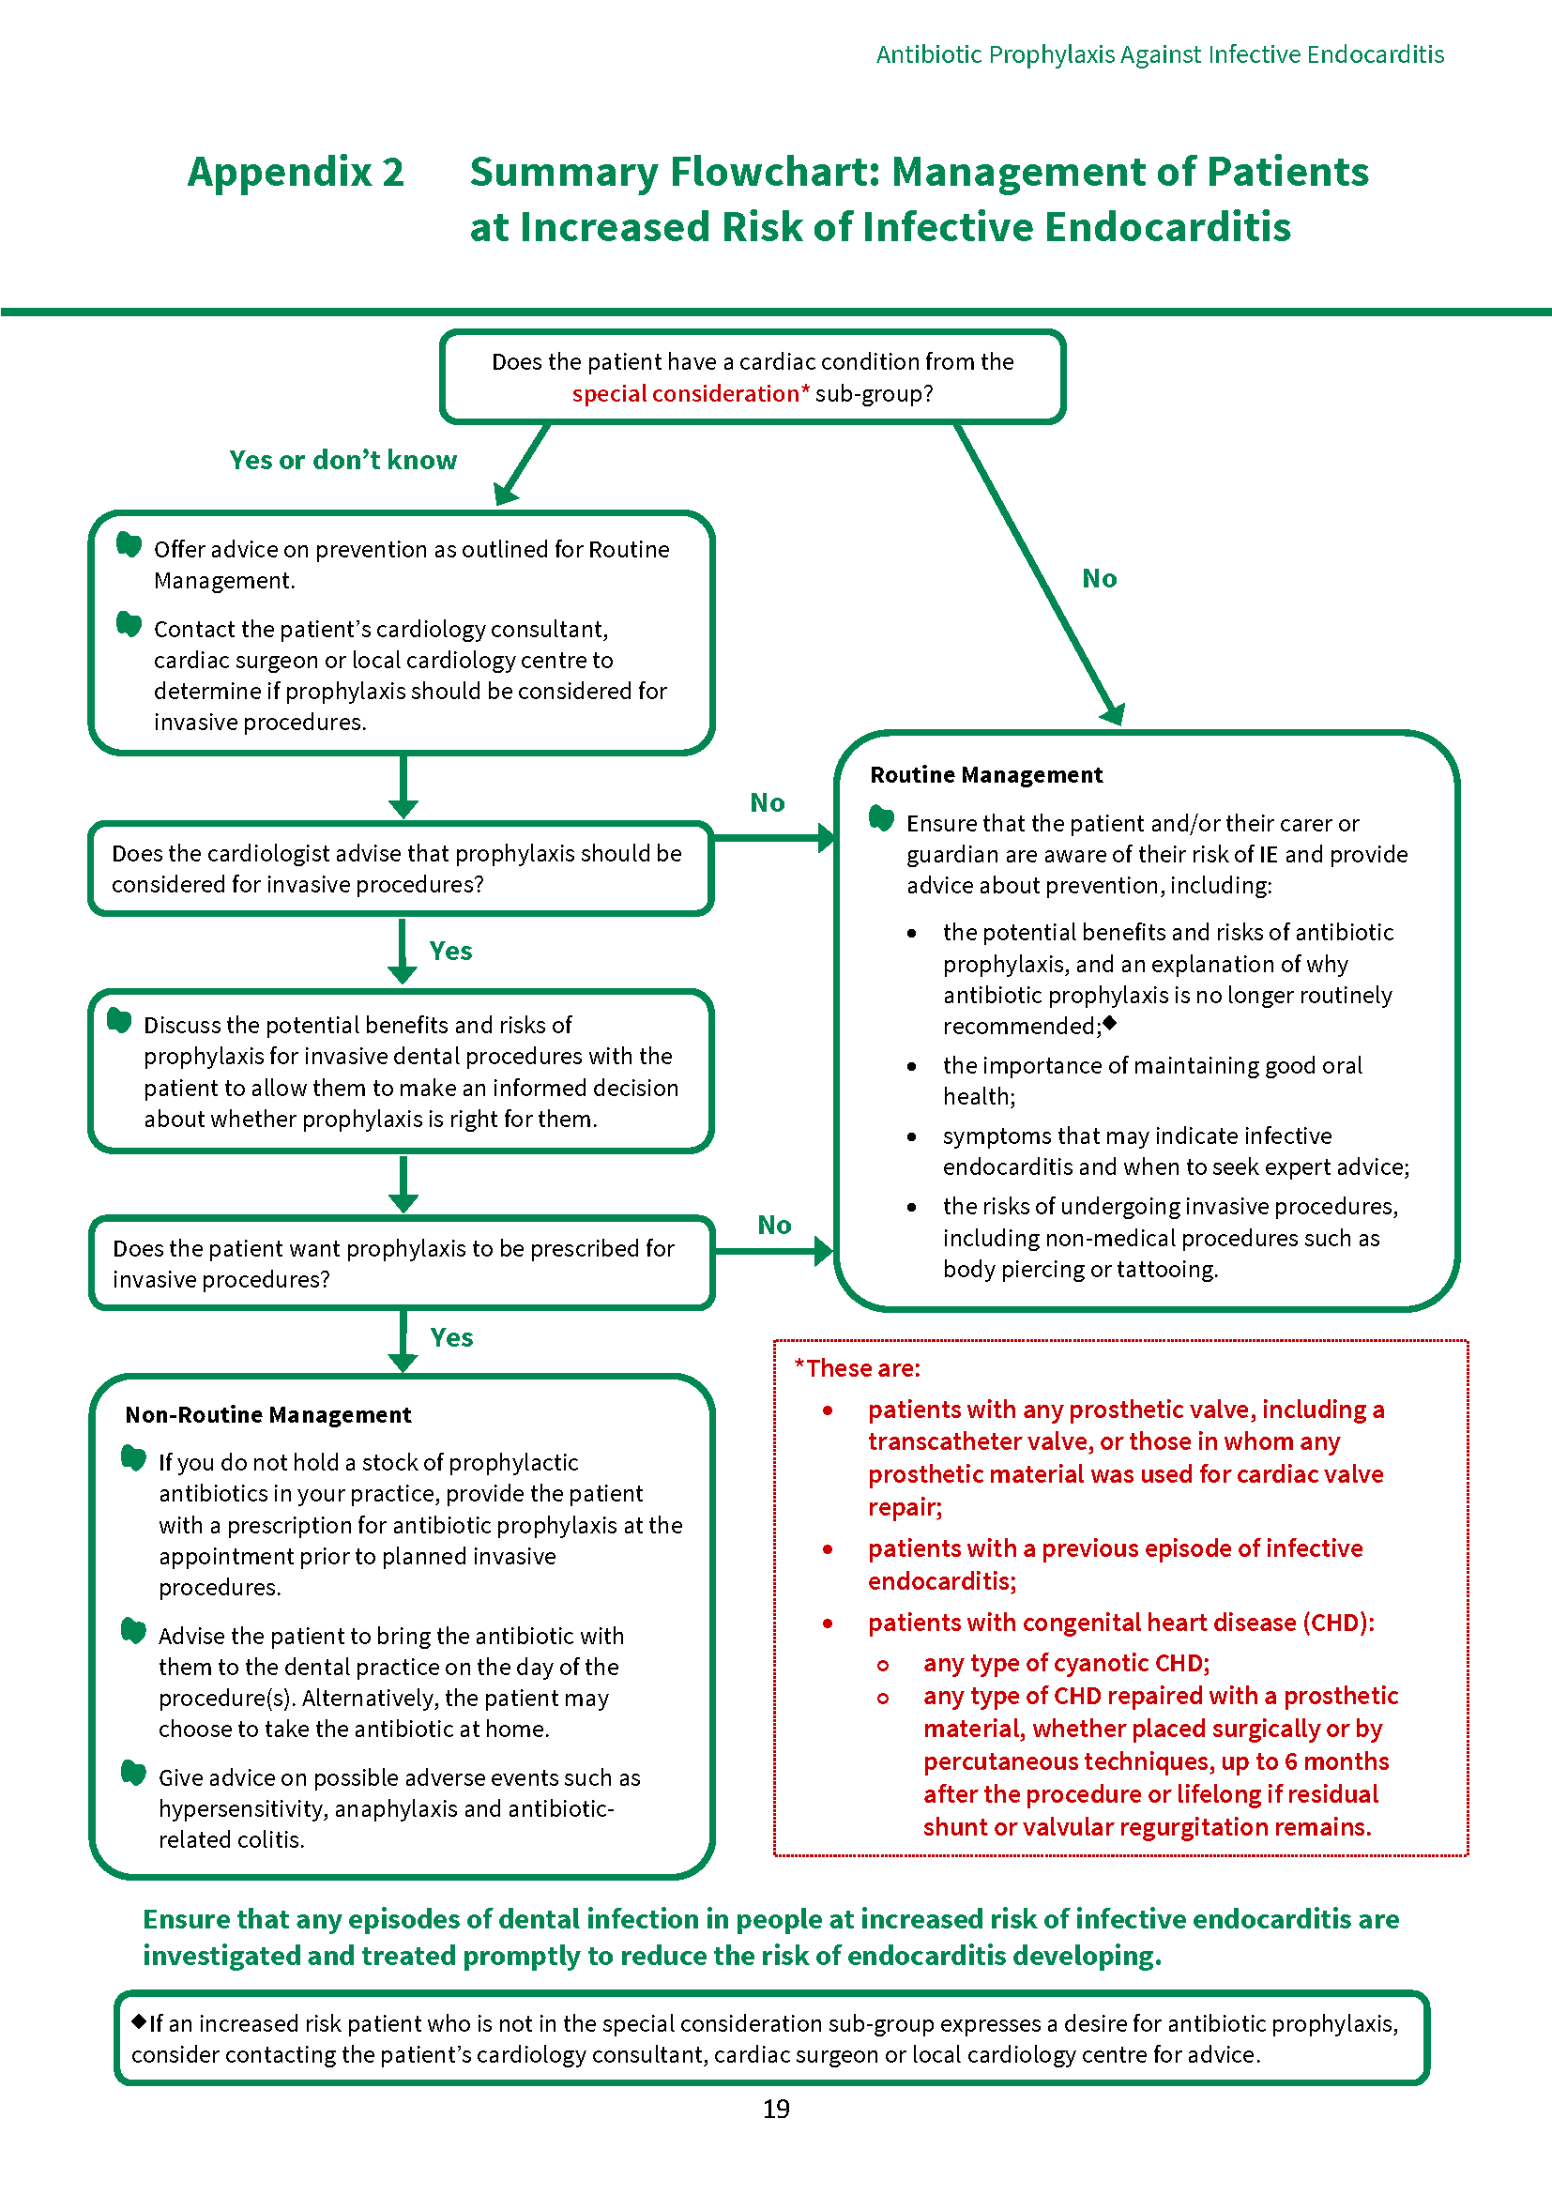

Appendix 3 Points to Cover During Antibiotic Prophylaxis Discussion with Patient
It is important that patients are not discouraged from undergoing dental treatment.
- Advise the patient that due to their heart condition/previous episode of infective endocarditis, there is a very small risk of developing infective endocarditis following an invasive dental procedure but ensure that they understand that the risk is very low.
- Explain that infective endocarditis is an infection of the lining of the heart, often involving the heart valves, caused mainly by bacteria which enter the blood from outside the body.
- Emphasise that infective endocarditis is a very rare but serious condition. The risk of infective endocarditis in the general population is less than 1 case per 10,000 people per year. However, their cardiac condition puts them at increased risk of developing infective endocarditis.
The figure below may help you to explain risk to patients.
Risk | 1 in 10 | 1 in 100 | 1 in 1000 | 1 in 10,000 | 1 in 100,000
Frequency | Someone in your family | Someone in a street | Someone in a village | Someone in a small town | Someone in a large town
Illustration |  |  |  |  | 
Adapted from Risk Language and Dialects, Calman and Royston, BMJ 1997; 315:939
- Explain that having an invasive dental procedure, such as an extraction, may increase the chances of bacteria entering the bloodstream.
- Explain that everyday activities, such as toothbrushing, flossing and chewing can also cause transient bacteraemias and stress the importance of good oral hygiene to reduce the risk from oral bacteria.
- Give advice on prevention of infective endocarditis to all increased risk patients including:
  - the potential benefits and risks of antibiotic prophylaxis, and an explanation of why antibiotic prophylaxis is no longer routinely recommended;
    - Explain that dental procedures are no longer thought to be the main cause of infective endocarditis.
    - Explain that it is unclear whether antibiotic prophylaxis prevents infective endocarditis and therefore it may occur whether or not prophylaxis is given.
    - Explain that antibiotics can cause side effects, such as nausea, diarrhoea and allergic reactions and, in rare cases, anaphylaxis and antibiotic-related colitis. It may also be helpful to discuss the issues surrounding antibiotic resistance.
  - the importance of maintaining good oral health;
    - Explain the importance of maintaining good oral health to prevent infective endocarditis.
    - Highlight the importance of regular dental check-ups to ensure that any dental disease is treated before invasive dental surgery is required.
    - Emphasise that excellent oral hygiene is the best way to prevent oral diseases that could require invasive dental treatment and will also reduce the chance of oral bacteria getting into the blood stream.
    - Advise the patient to reduce the frequency of sugary snacks and drinks to prevent tooth decay.
  - the risks of undergoing invasive procedures, including non-medical procedures such as body piercing or tattooing.
- For all patients at increased risk of infective endocarditis, advise them to contact their GMP as soon as possible if they notice any of the following symptoms, particularly if they occur together as a flu-like illness:
- A high temperature (fever) of 38ºC or above
- Sweats or chills, especially at night
- Breathlessness, especially during physical activity
- Weight loss
- Tiredness (fatigue)
- Muscle, joint or back pain (unrelated to recent physical activity)
  - Emphasise that these symptoms are more likely to be caused by a less serious type of infection but should be investigated.
  - Ensure that the patient knows to tell any medical professional they seek advice from about any recent invasive dental treatment they may have had.
- Record all discussions with the patient in their clinical notes.
- For patients who are considering antibiotic prophylaxis as part of non-routine management, discuss the potential benefits and risks of antibiotic prophylaxis to allow them to make an informed decision.
  - Ensure patients are aware of the potential for hypersensitivity, anaphylaxis or antibiotic-associated colitis.
  - Ensure that the patient is aware that the antibiotic prophylaxis should be taken in the dental practice one hour prior to the planned procedure and that they will be required to stay in the practice in the intervening period.
  - Alternatively, the patient may choose to take the antibiotic at home. Consider suggesting they contact the practice prior to taking the antibiotic to confirm that the procedure will be going ahead.
  - Ensure that patients prescribed an antibiotic are aware that they should seek urgent medical attention if they develop colitis (diarrhoea, which can be severe)

Appendix 4 Patient Information
Practices might find it helpful to use this leaflet to provide information to patients at increased risk of infective endocarditis. This leaflet is available to download from www.sdcep.org.uk.
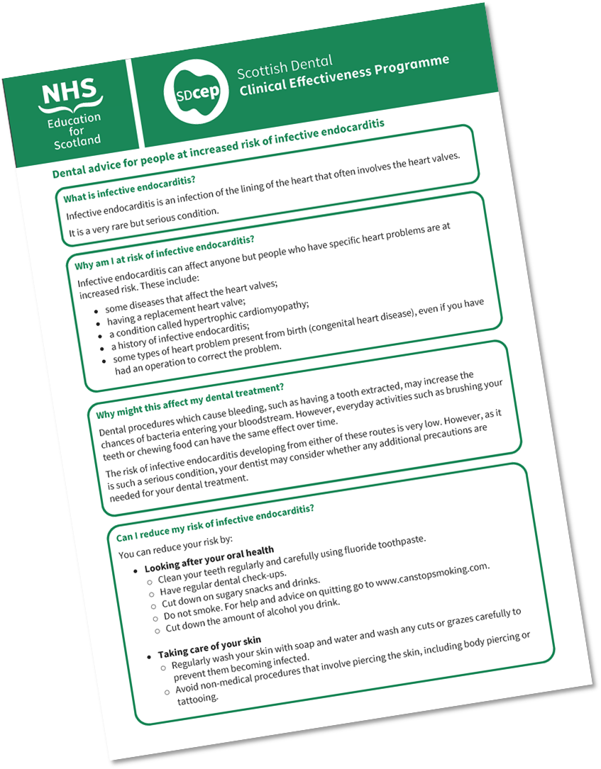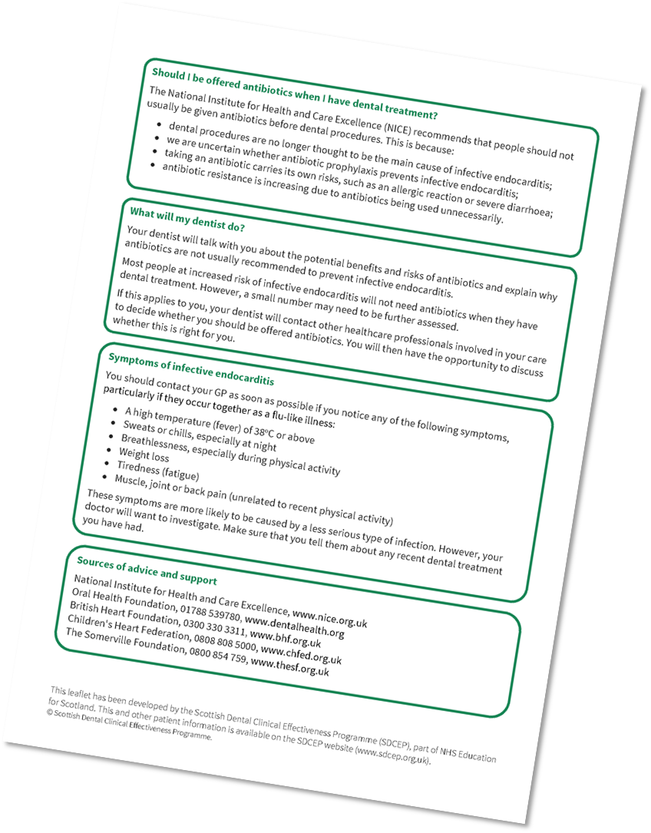

Appendix 5 Template Letter
This template letter can be adapted for use when contacting a patient’s cardiology consultant, cardiac surgeon or local cardiology centre. It is available to download from the SDCEP website, www.sdcep.org.uk.
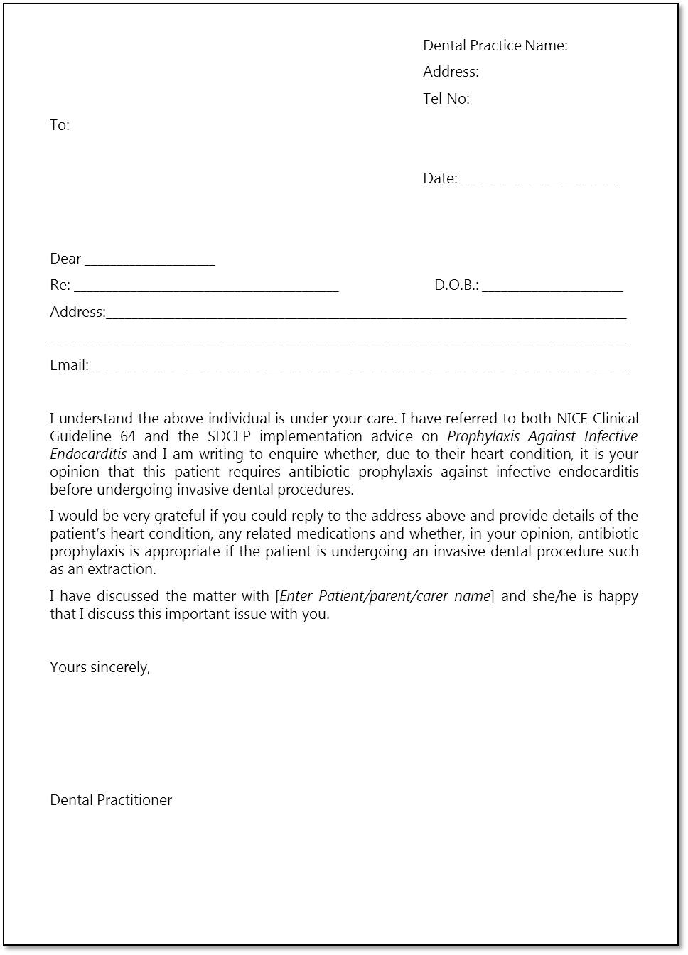

Appendix 6 Recommendations For Future Research
Infective endocarditis is a rare condition and a very small number of cases are thought to be related to invasive dental treatment. As such, a suitably designed and powered study to provide high quality evidence about the effectiveness of antibiotic prophylaxis before invasive dental procedures is unlikely to be feasible.
However, research to improve the evidence base in the following areas may be feasible and should be prioritised:
- risk of infective endocarditis in patients with the highest risk cardiac conditions;
- levels of bacteraemia caused by different invasive dental procedures;
- levels of bacteraemia caused by everyday activities such as toothbrushing;
- additional research into the microbiological epidemiology of infective endocarditis.
It may also be beneficial to establish a national database to monitor cases of infective endocarditis and this could inform some of the research areas highlighted above.

References
- DeSimone DC, Tleyjeh IM, Correa de Sa DD, et al. Temporal trends in infective endocarditis epidemiology from 2007 to 2013 in Olmsted County, MN. American Heart Journal. 2015;170(4):830-836.
- Selton-Suty C, Celard M, Le Moing V, et al. Preeminence of Staphylococcus aureus in infective endocarditis: a 1-year population-based survey. Clinical Infectious Diseases. 2012;54(9):1230-1239.
- Thornhill MH, Jones S, Prendergast B, et al. Quantifying infective endocarditis risk in patients with predisposing cardiac conditions. European Heart Journal. 2018;39(7):586-595.
- Tleyjeh IM, Steckelberg JM, Murad HS, et al. Temporal trends in infective endocarditis: a population-based study in Olmsted County, Minnesota. Journal of the American Medical Association. 2005;293(24):3022-3028.
- Lalani T, Chu VH, Park LP, et al. In-hospital and 1-year mortality in patients undergoing early surgery for prosthetic valve endocarditis. JAMA Internal Medicine. 2013;173(16):1495-1504.
- Murdoch DR, Corey GR, Hoen B, et al. Clinical presentation, etiology, and outcome of infective endocarditis in the 21st century: the International Collaboration on Endocarditis-Prospective Cohort Study. Archives of Internal Medicine. 2009;169(5):463-473.
- Duval X, Delahaye F, Alla F, et al. Temporal trends in infective endocarditis in the context of prophylaxis guideline modifications: three successive population-based surveys. Journal of the American College of Cardiology. 2012;59(22):1968-1976.
- Mylonakis E, Calderwood SB. Infective endocarditis in adults. The New England Journal of Medicine. 2001;345(18):1318-1330.
- Delahaye F, M'Hammedi A, Guerpillon B, et al. Systematic Search for Present and Potential Portals of Entry for Infective Endocarditis. Journal of the American College of Cardiology. 2016;67(2):151-158.
- Duval X, Alla F, Hoen B, et al. Estimated risk of endocarditis in adults with predisposing cardiac conditions undergoing dental procedures with or without antibiotic prophylaxis. Clinical Infectious Diseases. 2006;42(12):e102-107.
- Tubiana S, Blotiere PO, Hoen B, et al. Dental procedures, antibiotic prophylaxis, and endocarditis among people with prosthetic heart valves: nationwide population based cohort and a case crossover study. British Medical Journal. 2017;358:j3776.
- NICE Guideline 64. Prophylaxis against infective endocarditis: Antimicrobial prophylaxis against infective endocarditis in adults and children undergoing interventional procedures. National Institute for Health and Care Excellence; 2008. Updated 2015. Amended 2016; www.nice.org.uk/guidance/cg64. Accessed 17 August 2018.
- Thornhill MH, Dayer MJ, Forde JM, et al. Impact of the NICE guideline recommending cessation of antibiotic prophylaxis for prevention of infective endocarditis: before and after study. British Medical Journal. 2011;342:d2392.
- British National Formulary. 75 ed. London: BMJ Group and Pharmaceutical Press; 2018.
- Drug Prescribing For Dentistry. Scottish Dental Clinical Effectiveness Programme; 2016; www.sdcep.org.uk/published-guidance/drug-prescribing. Accessed 17 August 2017.
- Dayer MJ, Jones S, Prendergast B, Baddour LM, Lockhart PB, Thornhill MH. Incidence of infective endocarditis in England, 2000-13: a secular trend, interrupted time-series analysis. Lancet. 2015;385(9974):1219-1228.
- Glenny AM, Oliver R, Roberts GJ, Hooper L, Worthington HV. Antibiotics for the prophylaxis of bacterial endocarditis in dentistry. The Cochrane Database of Systematic Reviews. 2013(10):CD003813.
- Habib G, Lancellotti P, Antunes MJ, et al. 2015 ESC Guidelines for the management of infective endocarditis: The Task Force for the Management of Infective Endocarditis of the European Society of Cardiology (ESC). European Heart Journal. 2015;36(44):3075-3128.
- Wilson W, Taubert KA, Gewitz M, et al. Prevention of infective endocarditis: guidelines from the American Heart Association. Circulation. 2007;116(15):1736-1754.
- Montgomery v Lanarkshire Health Board, (UKSC 11 2015); www.supremecourt.uk/cases/uksc-2013-0136.html. Accessed 17 August 2018.
- Standards for the Dental Team. General Dental Council; 2013;
www.gdc-uk.org/professionals/standards. Accessed 17 August 2018
- Gillick v West Norfolk & Wisbech AHA & DHSS [1985] 3 WLR (HL);
www.bailii.org/uk/cases/UKHL/1985/7.html. Accessed 20 August 2018.
- Age of Legal Capacity (Scotland) Act 1991;
www.legislation.gov.uk/ukpga/1991/50/contents. Accessed 20 August 2018.
- Prevention and Management of Dental Caries in Children. 2nd Edition: Scottish Dental Clinical Effectiveness Programme; 2018; www.sdcep.org.uk/published-guidance/caries-in-children. Accessed 17 August 2018.
- Lee P, Shanson D. Results of a UK survey of fatal anaphylaxis after oral amoxicillin. The Journal of Antimicrobial Chemotherapy. 2007;60(5):1172-1173.
- Thornhill MH, Dayer MJ, Prendergast B, Baddour LM, Jones S, Lockhart PB. Incidence and nature of adverse reactions to antibiotics used as endocarditis prophylaxis. The Journal of Antimicrobial Chemotherapy. 2015;70(8):2382-2388.
- Antibiotic prophylaxis in surgery. (SIGN publication no.104) Scottish Intercollegiate Guidelines Network (SIGN). 2008. Updated 2014; www.sign.ac.uk/sign-104-antibiotic-prophylaxis-in-surgery.html. Accessed 17 August 2018.
- Gould FK, Elliott TS, Foweraker J, et al. Guidelines for the prevention of endocarditis: report of the Working Party of the British Society for Antimicrobial Chemotherapy. The Journal of Antimicrobial Chemotherapy. 2006;57(6):1035-1042.

©Scottish Dental Clinical Effectiveness Programme
SDCEP operates within NHS Education for Scotland. You may copy or reproduce the information in this document for use within NHSScotland and for non-commercial educational purposes. Use of this document for commercial purposes is permitted only with written permission.
This resource may be made available, in full or summary form, in alternative formats and community languages. Please contact NHS Education for Scotland on 0131 656 3200 or email altformats@nes.scot.nhs.uk to discuss how we can best meet your requirements.
Scottish Dental Clinical Effectiveness Programme
Dundee Dental Education Centre,
Frankland Building,
Small’s Wynd,
Dundee DD1 4HN
Email: scottishdental.cep@nes.scot.nhs.uk
Tel: 01382425751 / 425771
Website: www.sdcep.org.uk

Details of the process used to select the antibiotic prophylaxis regimens recommended in this document are provided in Appendix 1.

